2025 NSAL Arizona

Classical Voice Competition

$2000 In Awards

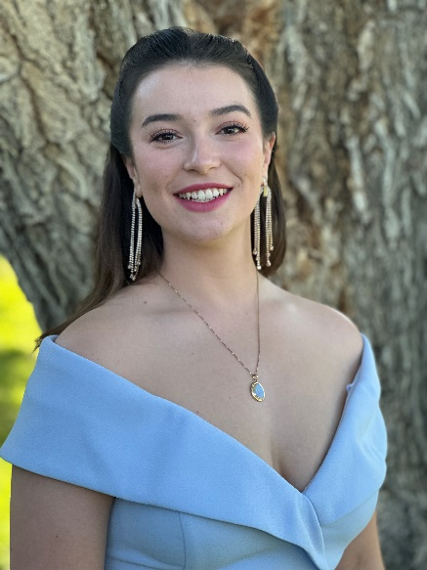

Alicia Werner, Soprano

2024 NSAL Classical Voice 19-22

Alicia is currently pursuing her bachelor's degree in vocal performance at Arizona State

University, studying with Stephanie Weiss. After completing her degree in the Spring, she plans

to begin working professionally with local Arizona companies, as well as apply for graduate

schools.

Alicia began singing classically in her freshman year of high school, and continues to grow and

develop her voice during her undergraduate studies. She has participated in a multitude of

programs and competitions, most recently learning a role with the 2023 Austrian American

Mozart Academy.

Alicia takes pride in bringing characters to life, and enjoys bringing new interpretations to every

performance: “It can be hard to embody everything about a character and their goals in just one

aria/lieder, especially if you’re performing a piece out of context, but I love to try and bring a

whole character, and their story, into view.”

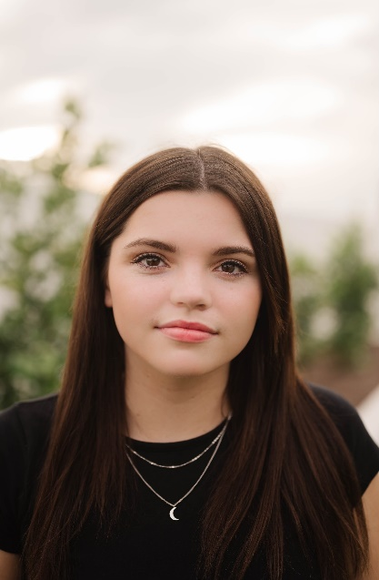

Taylor Peel

2025 Classical Voice 16-18

Taylor Peel is a senior at Highland High School. She has won numerous awards in the National Association of Teacher of Singing (NATS) classical, music theatre, and contemporary commercial divisions, advancing to the national finals in 2022. She was also a classical finalist in the Herberger Young Artists Competition in 2023. Taylor has appeared onstage in musicals at Mesa Community College and The Hale Center Theatre. She studies voice with Nichole Jensen.

**REQUIREMENTS**

**The National Society of Arts and Letters Arizona Annual Classical Voice Competition has been established and made available to young singers ages 16–18 and 19 - 22. Applicants must demonstrate exceptional talent and promise of future success. Applicants may apply as often as their age allows.**

**ELIGIBILITY**

**The applicant must:**

1. **Show proof of age with a copy of a valid Driver’s License, Birth Certificate or Passport.**
2. **Be at least 16 years old, but not older than 22 by December 1, 2024.**

**REPERTOIRE**

1. **Prepare a current, high-quality video of three (3) vocal selections from opera, art song or oratorio. One song must be in English and each of the songs must be contrasting in style and sung from memory. Total time: 10 minutes.** **Individual selections may not be edited, audio may not be enhanced, and the singer should be clearly visible.**
2. **Upload the completed video to You Tube. Identify yourself by name only. List your song titles and composers in the video description. You may submit one video with all three selections or three separate videos.**
3. **Complete the application form. Be clear about your commitment to a vocal career. Specify your plans for further study or other specific training.**
4. **Email your completed application, copies of your identification forms and the URL link to your YouTube video(s) to the NSAL Competition Chair:**

**Cathy Hauan**

[**cathyhauan@gmail.com**](mailto:cathyhauan@gmail.com)

* **A headshot is not required, but if you have one please send it along with your other application materials.**

**Application Deadline is December 1, 2024,** and notification of awards will be emailed shortly thereafter. The NSAL Arts in the Afternoon event will be held on January 25, 2025, and winners may be invited to perform.

**Applications due December 1, 2024**

**Competition Chair: Cathy Hauan**

[cathyhauan@gmail.com](mailto:cathyhauan@gmail.com)